Deployment Guide
Verizon- Automotive Data Orchestration Platform
Administrators Dashboard

Version | Author | Date
1.0 | Rajesh Nailwal and Manisha Sharma | January 31, 2022

Amantya Technologies

CONTENTS

1 PURPOSE 3
2 PRE-REQUISITES 3
3 OVERVIEW 3
4 Creation of Infrastructure 4
5 Building Images of Application 6
6 Initialization of Resources 9
6.1 Prepare Bastion Host 9
6.1.1 Installation of java 11 9
6.1.2 Installation of Postgres client version 13 9
6.1.3 Installation of Mongo client 9
6.1.4 Installation of Kafka client 9
6.1.5 Installation of eksctl client 10
6.1.6 Installation of Helm client 10
6.2 Creation of schema in Postgres Database 10
6.3 Creation of topics in Kafka 11
6.4 Create collections in Mongo DB and enable change stream on specific collections 13
6.5 Verify accessibility of ActiveMQ 15
7 Deploying ADOP Applications 16
7.1 Verifying the Deployment 18
8 VERIFY THE RUNNING STATUS OF APPLICATION 20
9 KEY TERMS 21
10 REFERENCES 21

PURPOSE
In this document, we are explaining the process to automate Spring Boot microservices builds using Jenkins pipeline and deploy into AWS EKS - Kubernetes Cluster with help of Kubernetes CLI plug-in.
We will use Spring Boot Microservices based Java application. We have already created a repository with source code + Docker file for this demonstration. The repository also has Jenkins file for automating the pre-requisites of this deployment.

PRE-REQUISITES

- Set up Jenkins along with AWS credentials related to a AWS user with required permissions so that Jenkins can use those credentials to create resources on AWS. Reference.
- Set up Jenkins pipelines.

Reference Document:

OVERVIEW
The brief steps to be performed on EC2 machine are as:
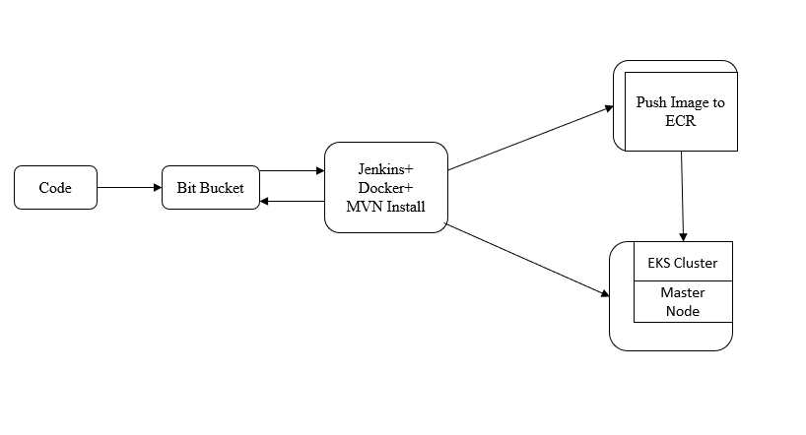

Creation of Infrastructure

Use ADOP-Infra pipeline from above attached document, This pipeline will create following resources on AWS:
- VPC
- Application Load Balancer and Target Groups
- Bastion Host (Ubuntu 20.04 based EC2 instance)
- RDS (Postgres)
- Document DB (Mongo DB)
- Amazon MSK (Kafka)
- Amazon MQ (Active MQ)
- EKS Cluster (Kubernetes Cluster)

- Select ADOP-Infra pipeline from Jenkins Dashboard:

- On the successful connection with the system, the screen will display:
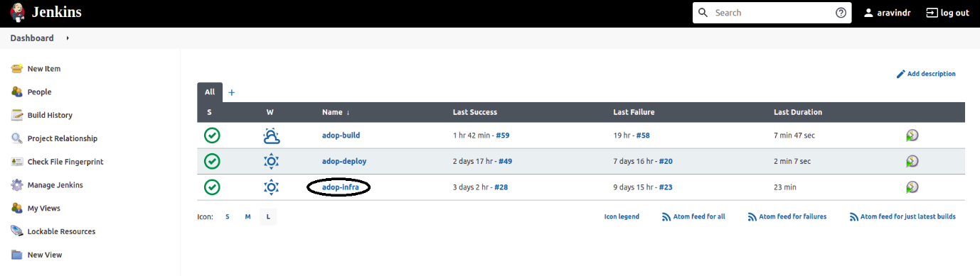
- Select Build with Parameters and give the required values and Click on Build:

- BRANCH_NAME: Name of git branch from where job will download IAAC code.
- AWS_Region: Select AWS Region where infrastructure to be deployed.
- ENVIRONMENT: Select type of environment type DEV or PROD.
- Required Broker Nodes: Select the number of broker nodes 2 or 3. (Only 2 is supported now).

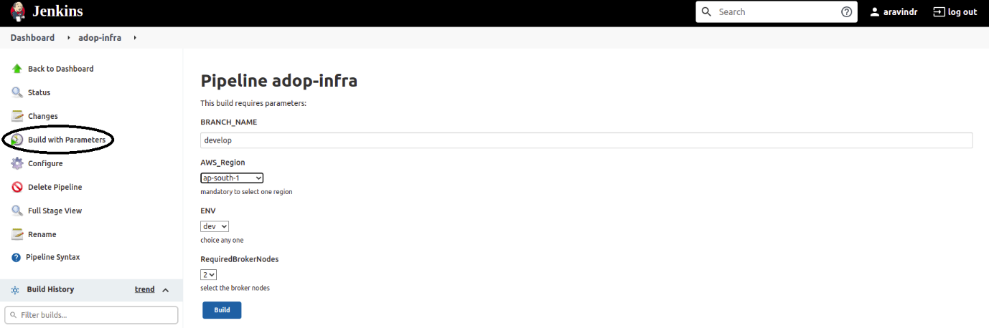

- Running the build and its different stages.

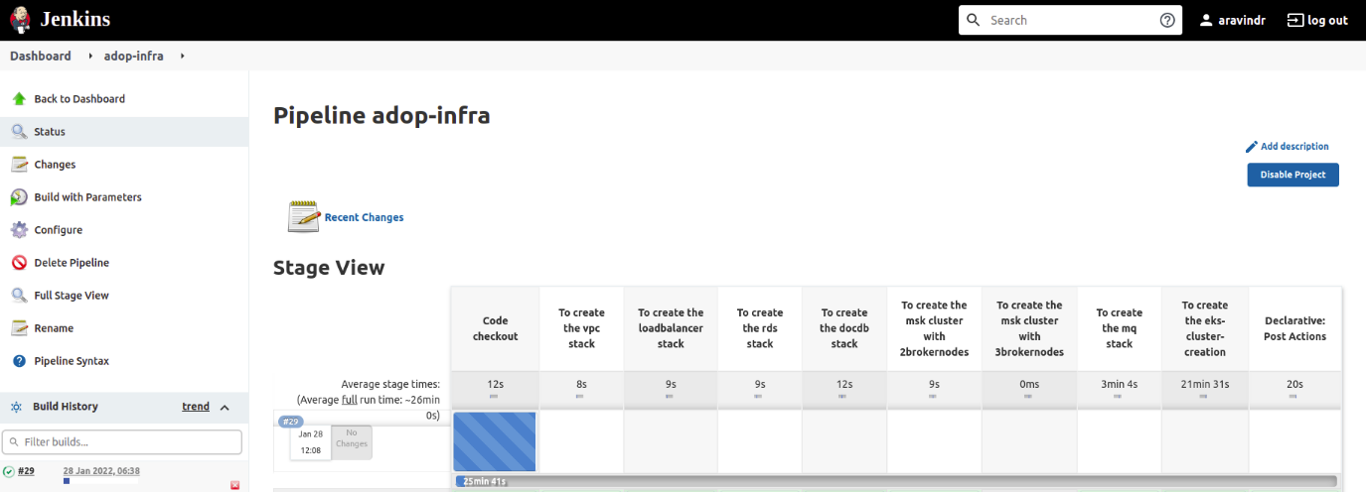

- The resource creation in Cloud formation:

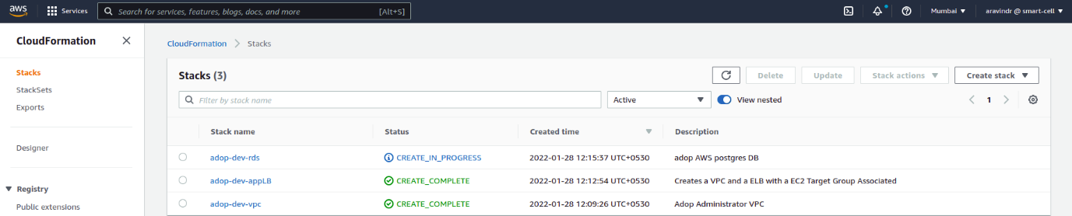

- The successful completion of ADOP-Infra pipeline on Jenkins:

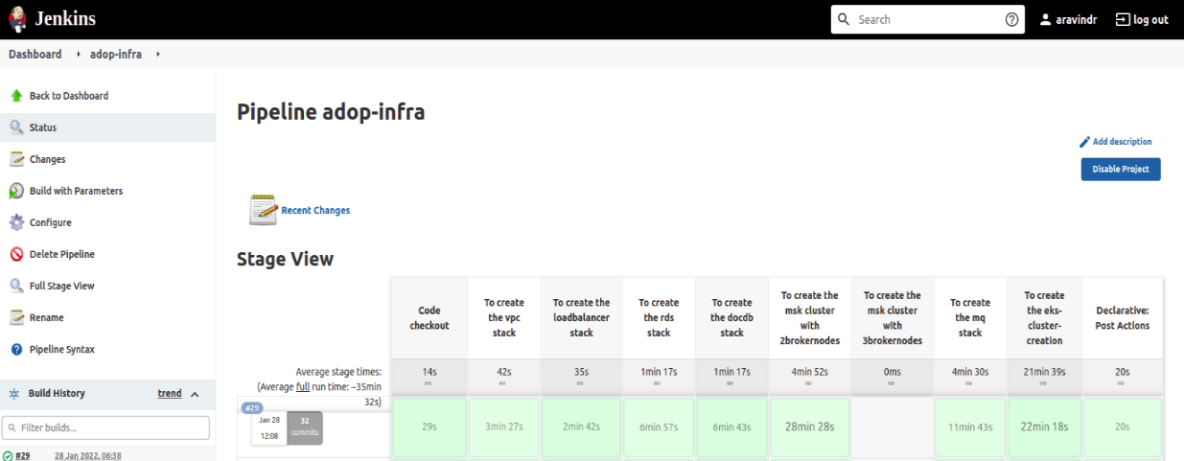

- Confirmation to successful completion of pipeline and creation of resources on Cloud formation:
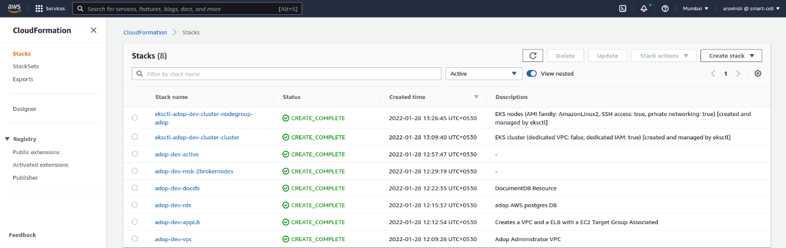

Building Images of Application

Required: Infrastructure created by ADOP-Infra pipeline should exists.
Use ADOP-Build pipeline (<Refer this document>). This pipeline will build Docker images and then push image in the Docker image repository. This pipeline is also going to update configuration in Docker images with Mongo (Document DB) and Postgres (RDS) database connections parameters, Kafka (Amazon MSK) and Active MQ (Amazon MQ) connection parameters:
- Select ADOP-Infra pipeline from Jenkins Dashboard:

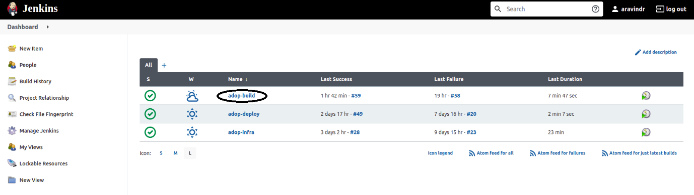
- Select Build with Parameters and give the required values and Click on Build:

- BRANCH_NAME: Name of git branch from where job will download Application code, docker files and helm charts.
- AWS_Region: Select AWS Region where infrastructure exists and we are supposed to deploy the applications in that region.
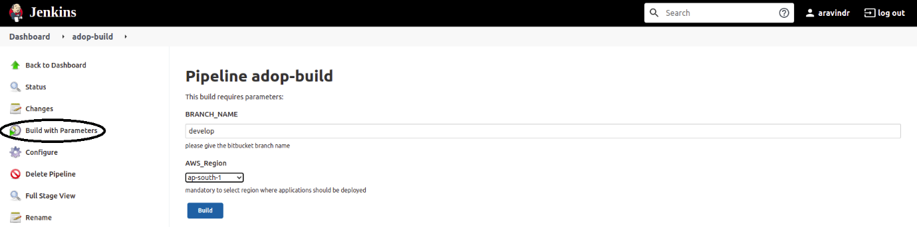

- See the running build and its different stages:

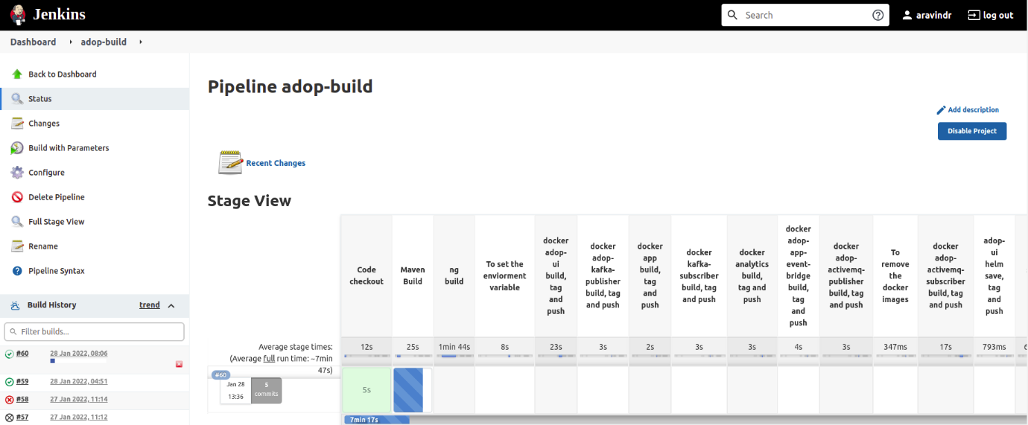

- Below is the successful completion of ADOP-Build pipeline on Jenkins:

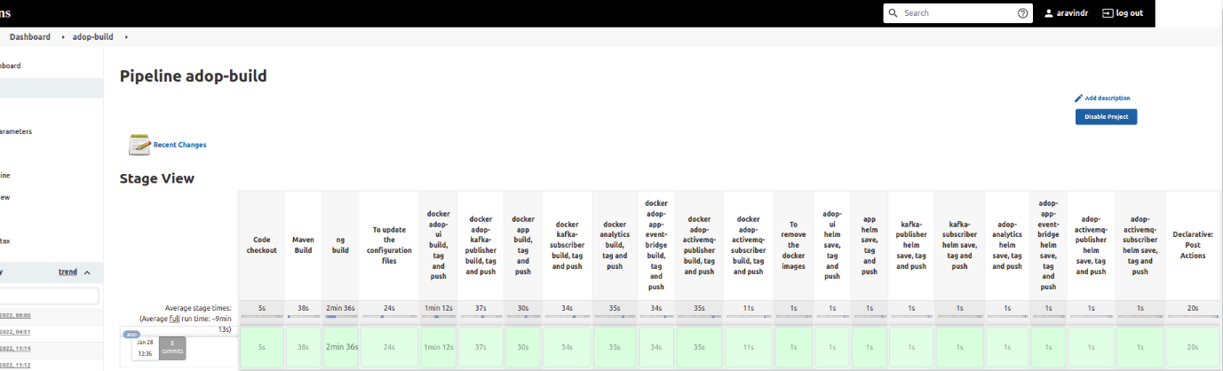

Below is the docker images and helm charts pushed in Docker container repository (For example: Amazon ECR) after successful build:

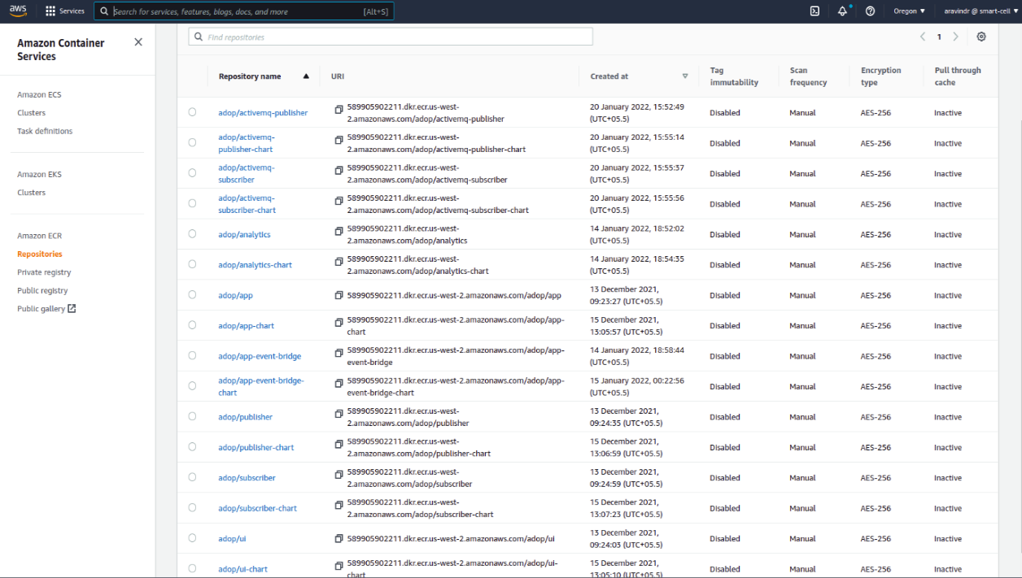

Initialization of Resources

The following Steps are required to be followed before deploying application:
- Create schema in Postgres database.
- Create topics in Kafka.
- Create collections in Mongo DB and enable certain collections to modify change stream.
- Verify accessibility of ActiveMQ.
As none of these resources can be accessed from outside of VPC so we can use the Bastion host on same VPC to access these resources.

Prepare Bastion Host

Install required utilities or software on Bastion host to access Postgres, Kafka and Mongo DB. (Below mentioned steps are for Ubuntu 20.04)

Installation of java 11
sudo apt install openjdk-11-jre-headless

Installation of Postgres client version 13
sudo apt update
sudo apt -y upgrade
Reboot machine
wget --quiet -O - https://www.postgresql.org/media/keys/ACCC4CF8.asc | sudo apt-key add -
echo "deb http://apt.postgresql.org/pub/repos/apt/ `lsb_release -cs`-pgdg main" | sudo tee /etc/apt/sources.list.d/pgdg.list
sudo apt update
sudo apt -y install postgresql-client-13

Installation of Mongo client
sudo apt install mongodb-clients

Installation of Kafka client
wget https://archive.apache.org/dist/kafka/2.6.2/kafka_2.12-2.6.2.tgz
tar -xvzf kafka_2.12-2.6.2.tgz

Installation of eksctl client
curl --silent --location "https://github.com/weaveworks/eksctl/releases/latest/download/eksctl_$(uname -s) amd64.tar.gz" | tar xz -C /tmp
Move the extracted binary to /usr/local/bin.
sudo mv/tmp/eksctl/usr/local/bin
eksctl version

Installation of Helm client
$ curl -fsSL -o get_helm.sh https://raw.githubusercontent.com/helm/helm/main/scripts/get-helm-3
$ chmod 700 get_helm.sh
$ ./get_helm.sh

Creation of schema in Postgres Database

- Get connection parameters from RDS:
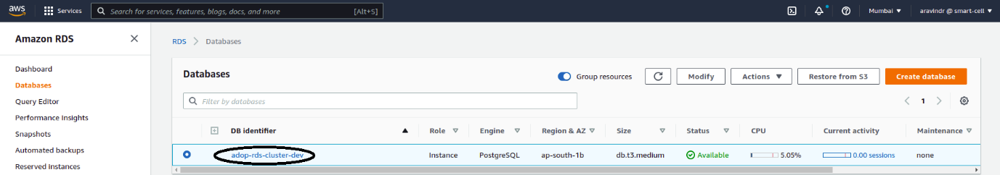
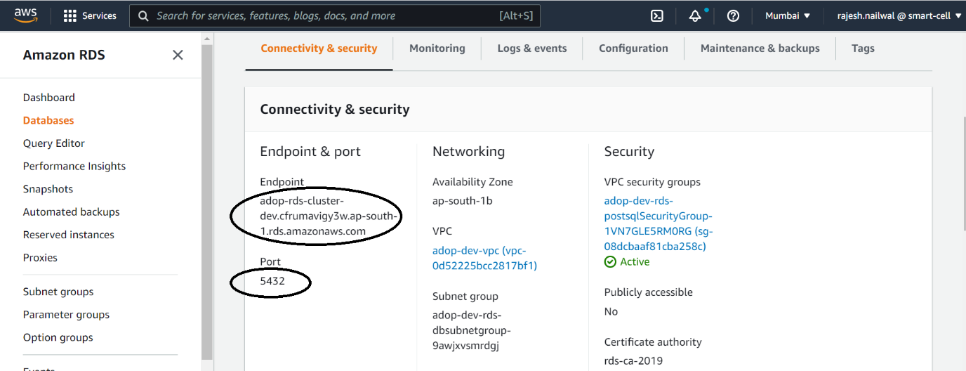
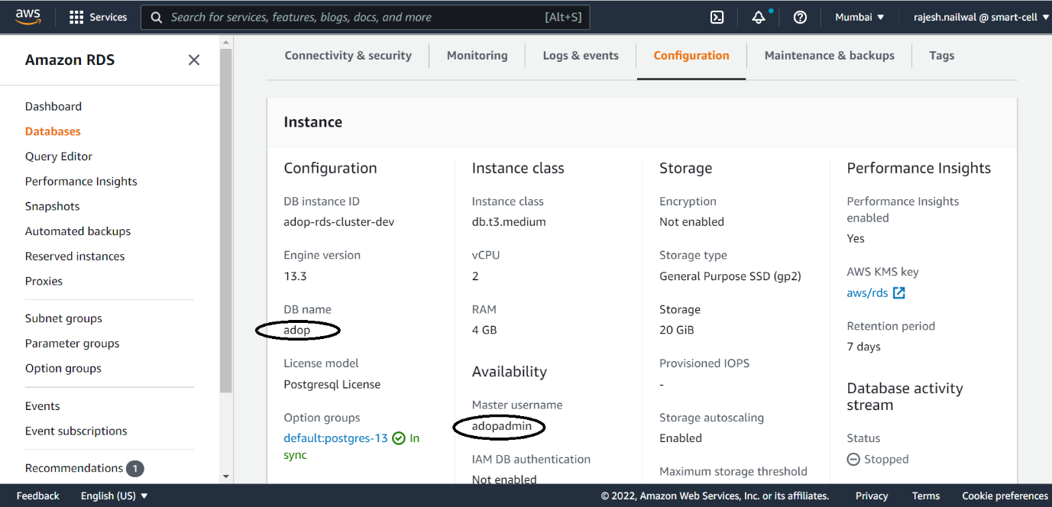

- Connect with database:
psql --host=adop-rds-cluster-dev.cfrumavigy3w.ap-south-1.rds.amazonaws.com --port=5432 --username=adopadmin --dbname=adop

- Create schema –
CREATE SCHEMA IF NOT EXISTS adop AUTHORIZATION adopadmin;

Creation of topics in Kafka
- Get connection parameters from Amazon MSK:

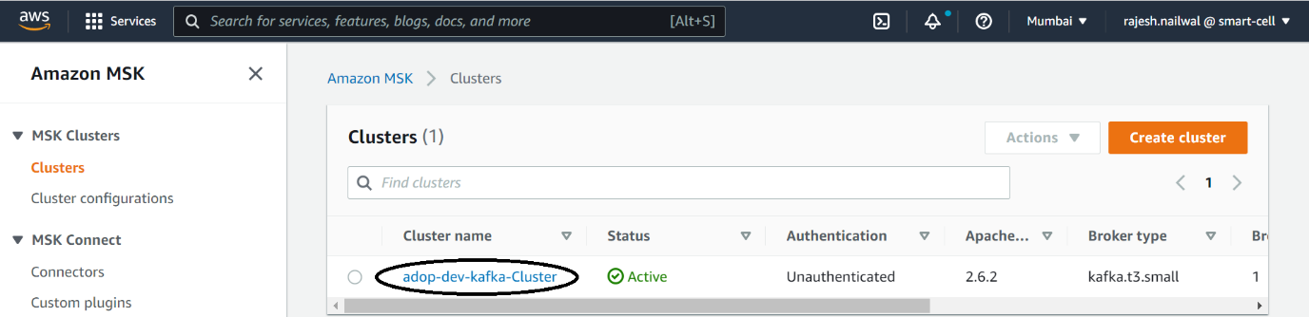
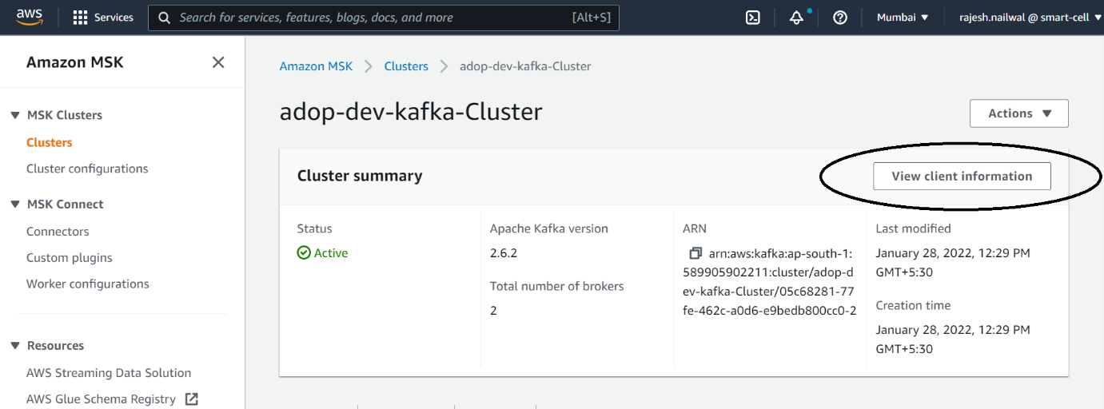
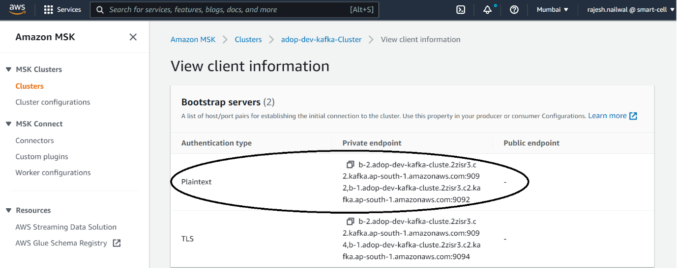

- Go to kafka_2.12-2.6.2/bin directory and create topics:

kafka-topics.sh --create --bootstrap-server b-2.adop-dev-kafka-cluste.2zisr3.c2.kafka.ap-south-1.amazonaws.com:9092,b-1.adop-dev-kafka-cluste.2zisr3.c2.kafka.ap-south-1.amazonaws.com:9092 --replication-factor 2 --partitions 2 --topic | ADOP-Stream
kafka-topics.sh --create --bootstrap-server b-2.adop-dev-kafka-cluste.2zisr3.c2.kafka.ap-south-1.amazonaws.com:9092,b-1.adop-dev-kafka-cluste.2zisr3.c2.kafka.ap-south-1.amazonaws.com:9092 --replication-factor 2 --partitions 2 --topic | Alarm
kafka-topics.sh --create --bootstrap-server b-2.adop-dev-kafka-cluste.2zisr3.c2.kafka.ap-south-1.amazonaws.com:9092,b-1.adop-dev-kafka-cluste.2zisr3.c2.kafka.ap-south-1.amazonaws.com:9092 --replication-factor 2 --partitions 2 --topic | Charging
kafka-topics.sh --create --bootstrap-server b-2.adop-dev-kafka-cluste.2zisr3.c2.kafka.ap-south-1.amazonaws.com:9092,b-1.adop-dev-kafka-cluste.2zisr3.c2.kafka.ap-south-1.amazonaws.com:9092 --replication-factor 2 --partitions 2 --topic | Driving
kafka-topics.sh --create --bootstrap-server b-2.adop-dev-kafka-cluste.2zisr3.c2.kafka.ap-south-1.amazonaws.com:9092,b-1.adop-dev-kafka-cluste.2zisr3.c2.kafka.ap-south-1.amazonaws.com:9092 --replication-factor 2 --partitions 2 --topic | Terrain
kafka-topics.sh --create --bootstrap-server b-2.adop-dev-kafka-cluste.2zisr3.c2.kafka.ap-south-1.amazonaws.com:9092,b-1.adop-dev-kafka-cluste.2zisr3.c2.kafka.ap-south-1.amazonaws.com:9092 --replication-factor 2 --partitions 2 --topic | Trip
kafka-topics.sh --create --bootstrap-server b-2.adop-dev-kafka-cluste.2zisr3.c2.kafka.ap-south-1.amazonaws.com:9092,b-1.adop-dev-kafka-cluste.2zisr3.c2.kafka.ap-south-1.amazonaws.com:9092 --replication-factor 2 --partitions 2 --topic | Weather
kafka-topics.sh --create --bootstrap-server b-2.adop-dev-kafka-cluste.2zisr3.c2.kafka.ap-south-1.amazonaws.com:9092,b-1.adop-dev-kafka-cluste.2zisr3.c2.kafka.ap-south-1.amazonaws.com:9092 --replication-factor 2 --partitions 2 --topic | Stream

Create collections in Mongo DB and enable change stream on specific collections

- Get connection parameters from Document DB
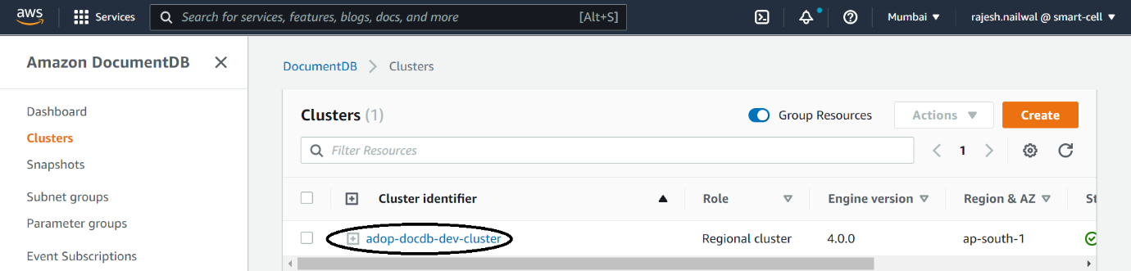

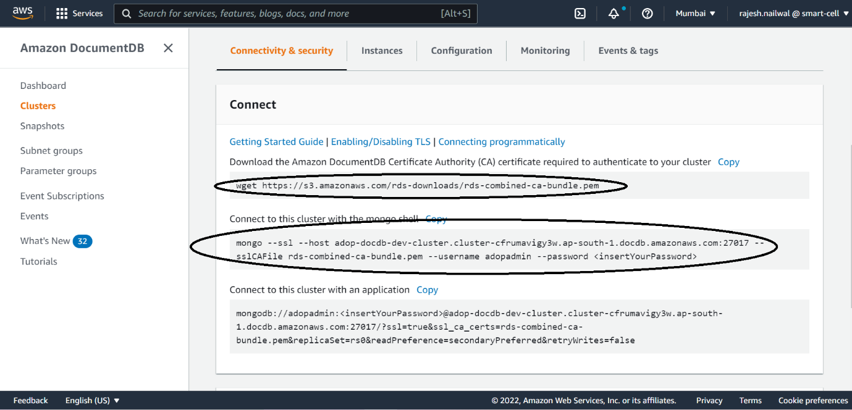
- Download certificates to connect with mongo DB:
wget https://s3.amazonaws.com/rds-downloads/rds-combined-ca-bundle.pem

- Connect with DB:
mongo --ssl --host adop-docdb-dev-cluster.cluster-cfrumavigy3w.ap-south-1.docdb.amazonaws.com:27017 --sslCAFile rds-combined-ca-bundle.pem --username adopadmin --password <insert Your Password>

- On mongo shell set to use ADOP database:
use adop

- Create mongo collections:
db.createCollection("AlarmEvent")
db.createCollection("ChargingEvent")
db.createCollection("DrivingEvent")
db.createCollection("TerrainChangeEvent")
db.createCollection("TripEvent")
db.createCollection("WeatherChangeEvent")
db.createCollection("TripRecord")
db.createCollection("AlarmRecord")

- Enable collections to modify change streams:

db.adminCommand({modifyChangeStreams: 1, database: "adop", collection: "TerrainChangeEvent", enable: true});
db.adminCommand({modifyChangeStreams: 1, database: "adop", collection: "TripEvent", enable: true});
db.adminCommand({modifyChangeStreams: 1, database: "adop", collection: "ChargingEvent", enable: true});
db.adminCommand({modifyChangeStreams: 1, database: "adop", collection: "AlarmEvent", enable: true});

Verify accessibility of ActiveMQ

- Get connection parameters from Amazon MQ.
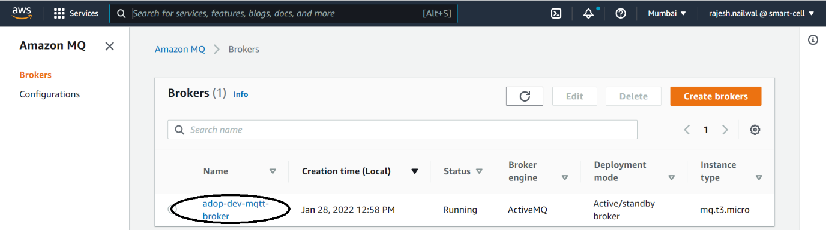
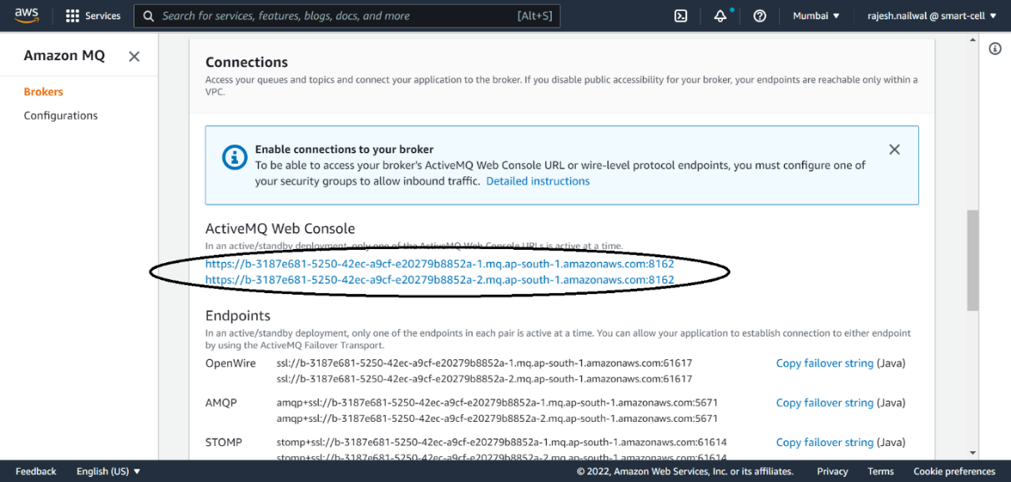
- Use ActiveMQ Web Console link on browser to use Active MQ.

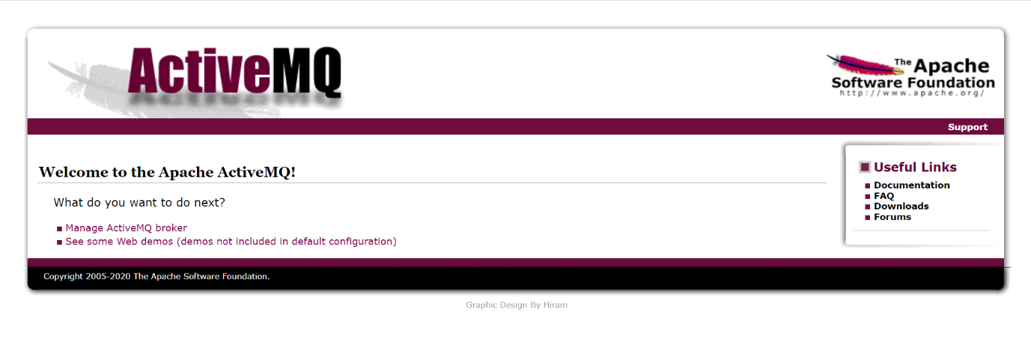

Deploying ADOP Applications

Required: Images created by ADOP-Build pipeline and helm charts should exist in Docker container repositories.
Use ADOP-Deploy pipeline (<Refer this document>). This pipeline will deploy images on EKS Cluster (Kubernetes cluster on AWS) with the help of helm charts.
- Select ADOP-Infra pipeline from Jenkins Dashboard:
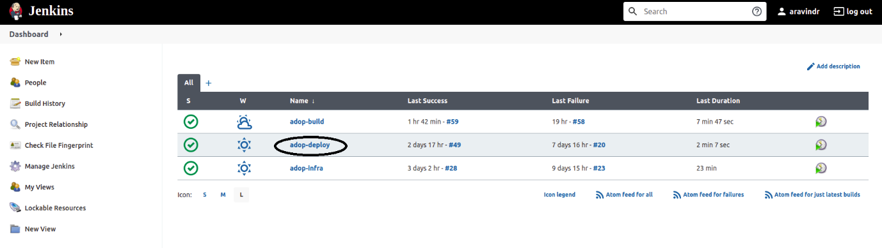

- Select Build with Parameters and give the required values and Click on Build:
  - BRANCH NAME: Name of git branch from where job will download provisioning scripts.
  - ENVIRONMENT: Select the environment for which application to be deployed. Two types of environments are supported dev and production.
  - AWS Region: Select AWS Region where infrastructure already exists and we are supposed to deploy the applications in that region.

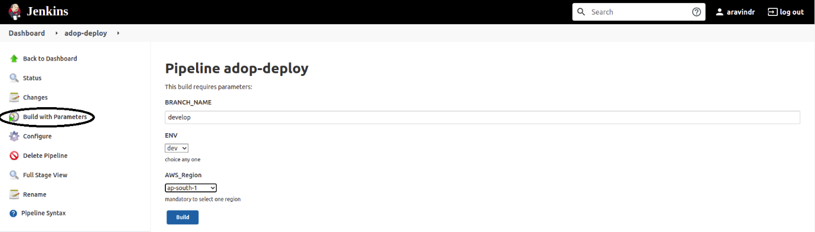

- Below is the running build and its different stages:

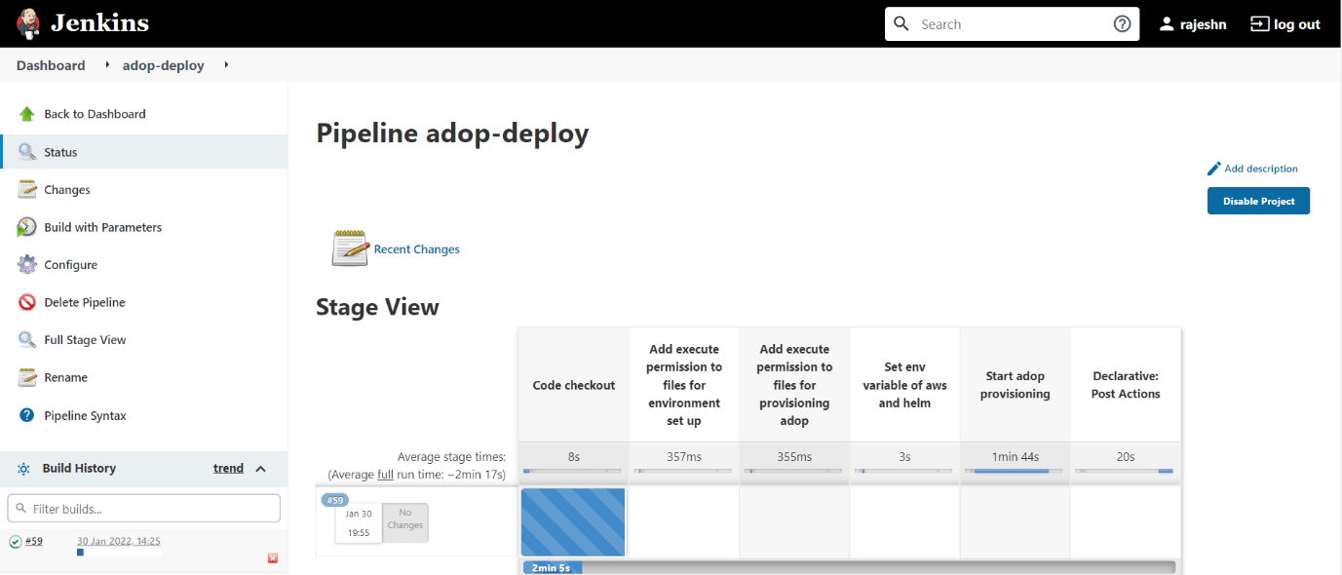

- Below snippet is representing the successful completion of ADOP-Deploy pipeline on Jenkins:

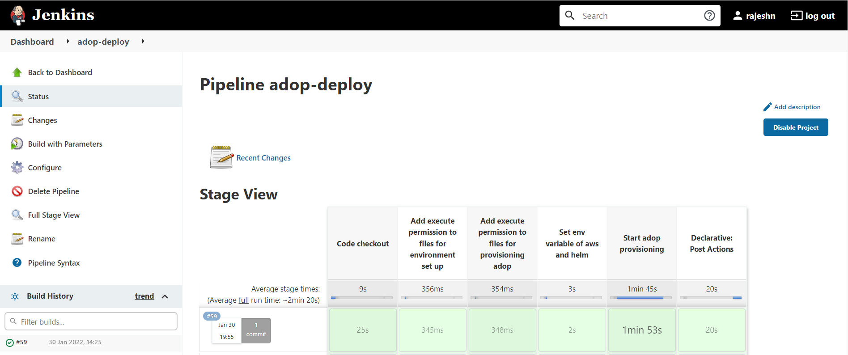

Verifying the Deployment

- Fetch EKS Cluster name from Amazon EKS

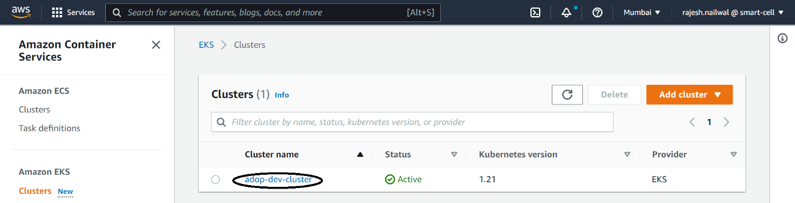

- Use Bastion Host to connect with Kubernetes cluster
- Update eksctl configuration:
aws eks update-kubeconfig –name adop-dev-cluster --region ap-south-1
- Fetch cluster nodes:
kubectl get nodes
- Fetch cluster pods:
Kubectl get pods
- Verify pod logs:
kubectl log <pod_name_from_kubectl_get_pods_command>
- Log in to pods to verify configurations:
Kubectl exect -it <pod_name_from_kubectl_get_pods_command> /bin/bash
- Verify pod configurations:
kubectl describe pods <pod_name_from_kubectl_get_pods_command>

- List of all Helm charts:
Helm list
- To uninstall Helm charts:
helm uninstall<space_separated_charts_list_to_be_removed_from_helm_list_command>

DATABASE INITIALISATION TO UPDATE RECORDS

- Login to Postgres SQL in server.
Example:
psql --host=adop-rds-cluster-dev.cfrumavigy3w.ap-south-1.rds.amazonaws.com --port=5432 --username=adopadmin --dbname=adop
password: Adminuei123^y

- For login, make the entries in Postgres SQL tables:

- OEM table
INSERT INTO adop.oem (oem_id, header_img, "name") VALUES (1, null, 'audi');
- Users table
INSERT INTO adop.users(user_id, contact_number, email, first_name, last_name, "password", profile_img, user_role, oem_id)VALUES(1, '9876543210', 'alex@gmail.com', 'Alex', 'James', 'alex@2021', null, 'driver', 1);

User will be able to login by using the above credentials.
- Check Vehicles data on Dashboard
Populate entries in some more table stated below:

Model | INSERT INTO adop.model (model_id, battery_power, fuel_type, latest_software_version, "name",plug_type, standard_battery_efficiency, "year", oem_id) VALUES(1, 700, 'Electric', '5.2.1', 'Audi A6 e-tron', 'Ultra Fast Type C Charger', 5, '2014-01-01', 1);
Vehicle | INSERT INTO adop.vehicle (vehicle_id, average_battery_efficiency, battery_manufacturing_date,car_img, current_battery_charge_status, dtc_event_count,is_latest_software_version, last_charging_level, last_service_date,next_service_date, score, software_version, total_charge_count, total_distance,total_power_consumed, vin, model_id) VALUES(1, 2.8, '2019/05/15',null,53, 11, true,75, '2019/09/21', '2020/04/20', 70, '5.2.1', 5,300, 69, 'WAUZZZ4B0N009071', 1);
Driver | INSERT INTO adop.driver(driver_id, aggressive_turning_percent_per_trip, avg_fwd_collision_warnings_tmp, harsh_breaking_percent_per_trip, name, profile_img, score, unsafe_following_percent_per_trip, vehicle_id)VALUES (1, 0, 0, 0, ‘Alex’, null, 0, 0, 1);
Power _usage _breakdown | INSERT INTO adop.power_usage_breakdown (power_usage_breakdown_id, total_power_consumed_by_ac, total_power_consumed_by_driving, total_power_consumed_by_ heating, total_power_consumed_by_others, vehicle_id)VALUES (0, 0, 0, 0, 0, 1);

- Check Individual vehicle analysis records in dashboard:
Populate the entries in below table-
Admin_Dashboard _analytics | INSERT INTO adop.admin_dashboard_analytics (adm_anlts_id, average_charging,average_efficiency,cc2_charging_percent,eighty_one_to_hundred_charging_count,eighty_one_to_hundred_pre_charge, eleven_to_eighty_pre_charge, fourty_one_to_sixty_charging_count, other_charging_percent, sixty_one_to_eighty_charging_count, total_charging,total_diagnostic_alarms, total_night_driving, total_season_driving, total_trips,total_vehicles, twenty_one_to_fourty_charging_count, type2_charging_percent,veh_raised_alarms, zero_to_ten_pre_charge, zero_to_twenty_charging_count, oem_id) VALUES(1, 0, 0, 0, 0, 0, 0, 0, 0, 0, 0, 0, 0, 0, 0, 0, 0, 0, 0, 0, 0, 1);
Registration_Details | INSERT INTO adop.registration_details(registration_details_id, address, area, city, "date", state, zipcode, vehicle_id)VALUES (1, '1017 Arlington Avenue Forrest City, AR 72335', 'Arlington Avenue', 'Forrest City', '2020-07-10', 'Arkansas United States', 72335, 1);

- MongoDB Steps:
MongoDB credential and collections:
mongo --ssl --host adop-docdb-dev-cluster.cluster-cfrumavigy3w.ap-south-1.docdb.amazonaws.com:27017 --sslCAFile rds-combined-ca-bundle.pem --username adopadmin --password <your-password>
use adop //our db name is adop
show collections //to list all the collections
db.collection_name.find() //to see collection data

VERIFY THE RUNNING STATUS OF APPLICATION

Once the build is successful, go to browser and enter the load balancer DNS to open the ADOP application on browser.

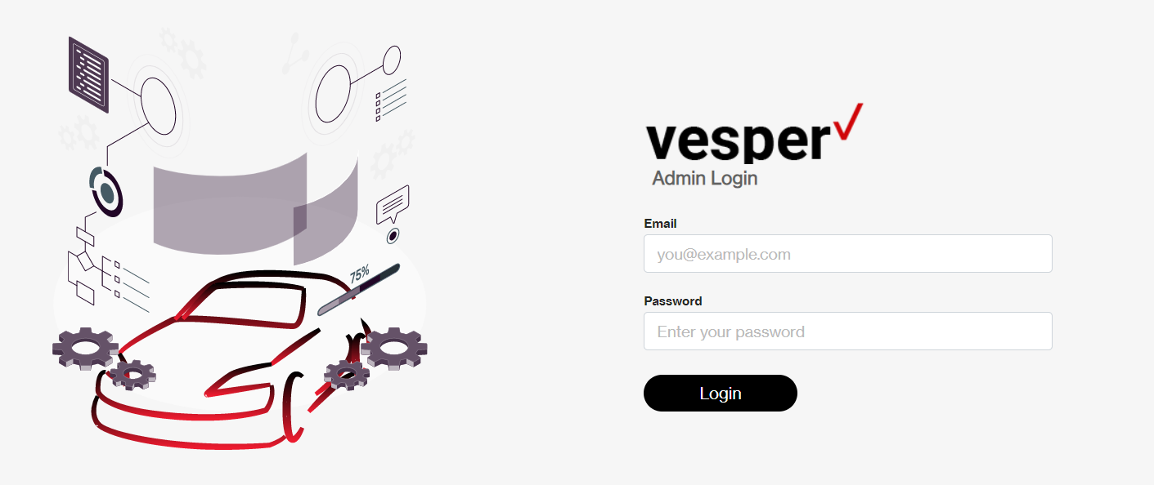

KEY TERMS

KEY TERMS
TERM | DEFINITION
ADOP | Automotive Data Orchestration Platform
CLI | Command Line Interface
EKS | Elastic Kubernetes Service
RDS | Relational Database Service
VPC | Virtual Private Cloud

REFERENCES

REFERENCES
DOCUMENT NAME | DESCRIPTION | LOCATION
Jenkins- AWS Credentials and Jenkins Pipelines | Setting up Jenkins with AWS Credentials and Setting up Jenkins Pipelines
Functional Requirement Specification | Detailed Description of whole project

